Exercise 1
Assumptions
- The insurance company is not interested in those persons who are not customers, even they are hit by a car in an accident.
- Every accident is associated with at least one driver and one car.
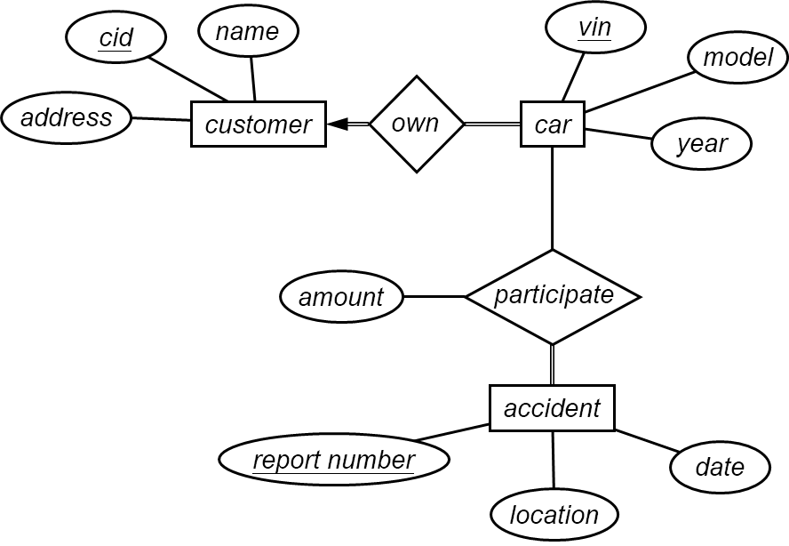
Schema:
- $customer=(\underline{cid},name,address)$
- $car=\left(\underline{vin},model,year,cid\right)$
- $accident=(\underline{r_number},location,date)$
- $participate=(\underline{vin,r_number},amount)$

Follow-up discussion
Suppose the road-traffic-control department wants to modify the ER model to meet the following requirements
- all persons not only car owners,
- the drivers of every car in each accident,
- some non-drivers may involve in some accidents,
- some cars without a driver may be hit in some accidents.
What is the problem of each following design? The relationship set “own” and all attributes are omitted.
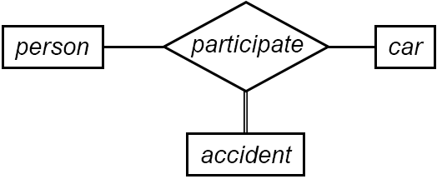
This model cannot the roll of the person, a driver, or a non-driver. It cannot prevent the co-occurrence of $(p1,c1,a1)$ and $(p1,c2,a1)$. Does $p1$ drive two different cars in an accident?
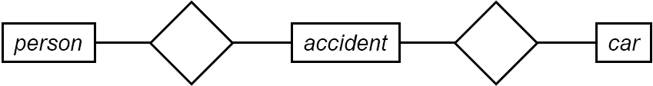
This model cannot express the driver.
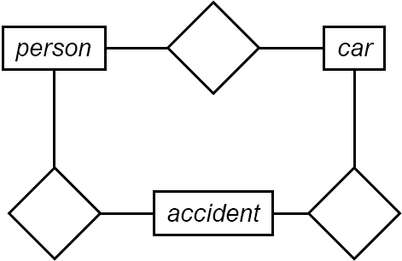
This model is ambiguous if one person drives multiple cars and involves into different accidents.
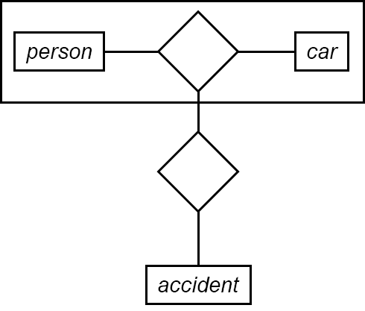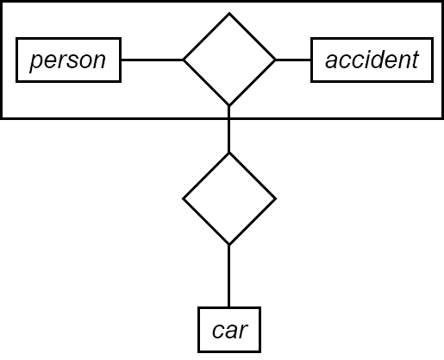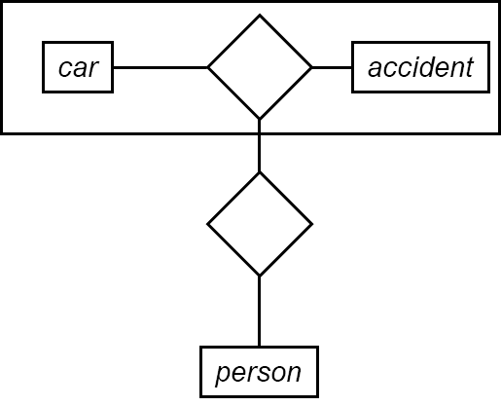
These models cannot express non-drivers and unmanned cars at the same time.
In fact, the requirements are beyond the limit of ER model.

Exercise 2
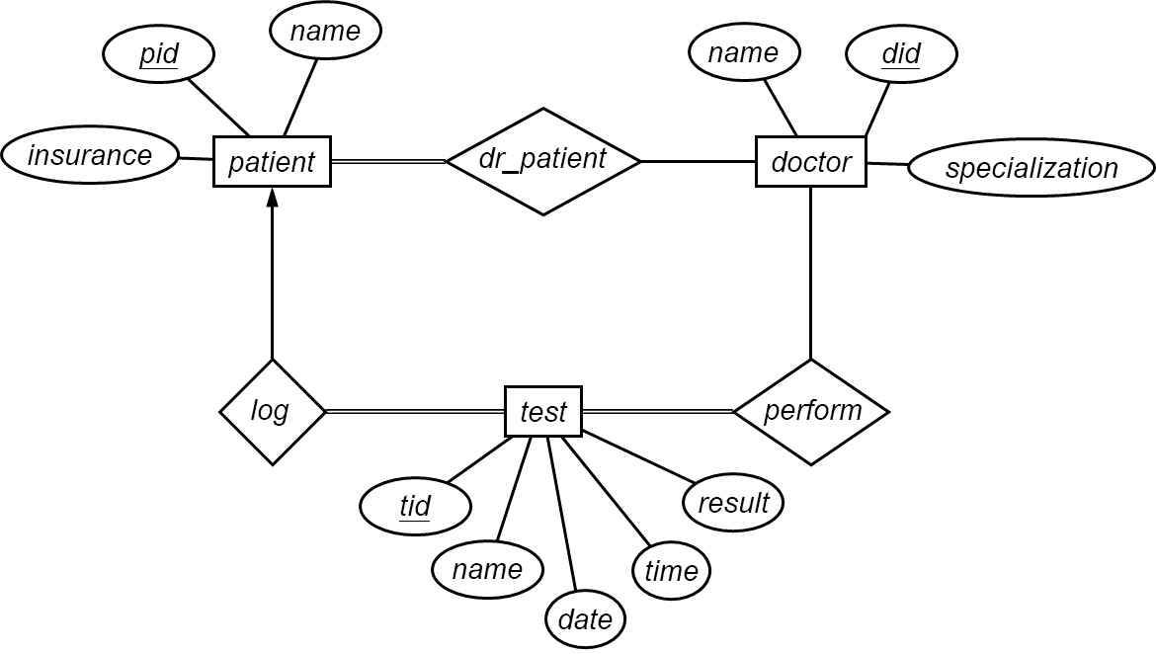
Schema:
- $patient=(\underline{pid},pname,insurance)$
- $doctor=(\underline{did},dname,specialization)$
- $test=(\underline{tid},tname,date,time,result,pid)$
- $dr_patinet=(\underline{pid,did})$
- $perform=(\underline{did,tid})$

Exercise 3:
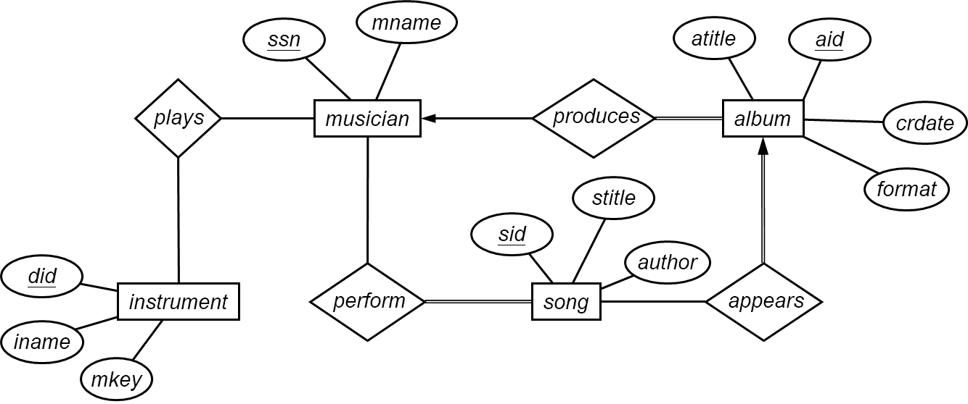
Schema:
- $musician=(\underline{ssn},mname)$
- $album=(\underline{aid},atitle,crdate,format,ssn)$
- $song=(\underline{sid},stitle,author)$
- $instrument=(\underline{did},iname,mkey)$
- $appears=(\underline{sid},aid)$
- $perform=(\underline{ssn,sid})$
- $plays=(\underline{did,ssn})$
Pay attention to the key of $appears$.

